# TOPOLOGICAL SORTING

It is always in directed graph,

1 -> 2 -> 3 is correct order

It is always in direct graph as in undirected 1-2 as we can move from 2 to 1 as well that is not right order so that is why it is always in directed graph

U -> V , pehle U aye ga phr V aye ga

There should not be any cycle in directed graph.

As you know, U-> V, V ->U that created problem if we do that in directed graph.

Apny is trha numbers ko arrange krky likhna k U->V satisfy rhy pury graph m

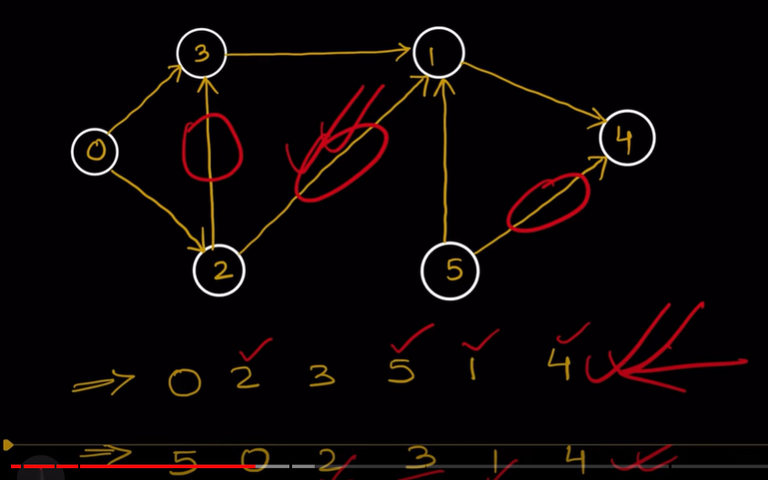jinki indegree zada h wo bad m ary ha

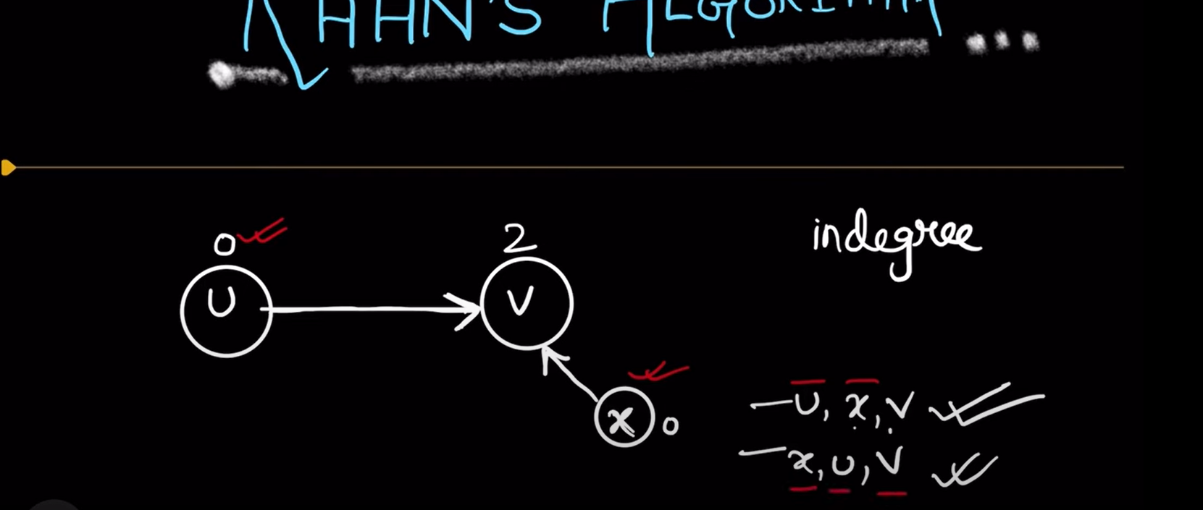

KAHN’S ALGO

Indegree ko store krlya or usko zero krna ha jiska zero huga usko que m dlay gy, or jo visit huta jye ga uska indgree minus by 1.